Student Number: 5626

**Critically examine the issues and opportunities for women in esports.**

**Esports history and growth**

As stated by Eugen eSports involves competitive gaming where individuals or teams play against each other, often in organized, multiplayer settings (Sirotin, 2024). Computer and game first went hand in hand in 1958 (Malliet, De Meyer 2011), ever since it was inevitable that computer games would be taken competitively. Those with real or perceived skill will see an asymmetrical flow of “perks” in their favor (Henrich, Gil-White 2001). Humans will naturally strive to be competitive amongst one another to gain status and prestige amongst their peers.

The first esports tournament was hosted in 1972, the “Intergalactic Spacewar Olympics.” Twenty-Four players met on this day to compete in “Spacewar!” (Larch 2023). The first ever victor of an Esports tournament was Slim Tovar and Robert E. Mass, and free-for-all winner Bruce Baumgart (Farokhmanesh, 2012) who is male. Esports has been rapidly growing, As stated by (Goh, 2023) The inaugural Olympic Esports Week (OEW) takes place in Singapore from 22-25 June 2023 and in 2022, the global eSports market was valued at just over 1.38 billion U.S. dollars (Gough, 2023). Another example of Esports growth was League of Legends World Championship in 2023. With a remarkable peak of 6.4m, Worlds 2023 is the most-popular esport event of all time (Daniels, 2023). 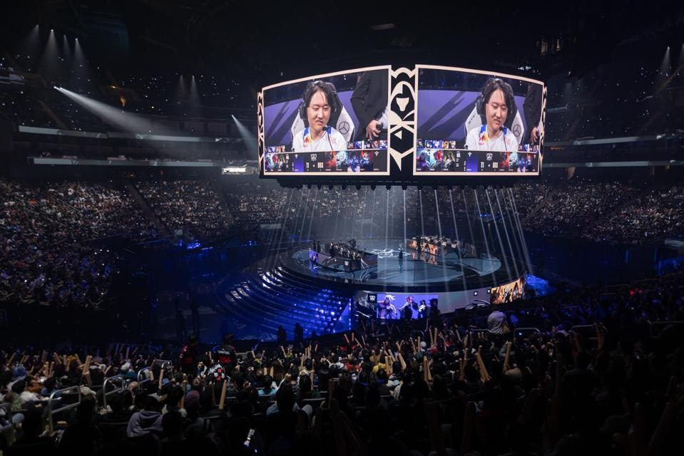

Although Esports is a rapidly growing industry it has been dominated by men since its inception, A 2019 study on Gender and Gaming stated that almost half (35%) of the gamer population are female, yet only 5% of that population are considered professional esports athletes (Badillo, 2023). In this paper I hope to discuss and evaluate women in Esports, including the issues that face the industry in history and today but also the opportunities that women have been given and the ones emerging today.

**Possible reasoning on why women are underrepresented.**

In society women have been discriminated against since the birth of civilization, it wasn’t until the 10th January 1918 the House of Lords gave approval for women over the age of thirty to have the right to vote (Brain, n.d). It was deemed in early society that men where superior and so women and men did not have equal rights and privileges. This issue still stands today where women are still fighting for equal pay, median hourly pay for full-time employees was 7.7% less for women than for men in April 2023 (Francis-Devine, Brione, 2024), this is just one of the multiple areas outside of Esports where women are treated differently compared to men today.

There is little reasoning as to why women are separated in Esports, unlike physical sport where adult males are faster, stronger, more powerful than females because of fundamental sex differences in anatomy and physiology dictated by sex chromosomes (Hunter, 2023). Esports are a mental and fine motor skills test which is lightly impacted by anatomy. There is an argument to be made that women may be at an advantage in gaming due to a statement by (Goldman, 2017) that states; Women’s reading comprehension and writing ability consistently exceed hat of men, on average. They outperform men in tests of fine-motor coordination and perceptual speed. These skills are crucial in professional Esport titles where fractions of a second can separate the skill levels of professional play.

Females who play with a male partner are less confident in their skills and often focus on supporting their partner’s advancement (Ratan, et al, 2015). It’s certain that females that pick-up gaming from their partners are usually enticed to play supports; Annie sees other female players she knows (as well as herself) relegated to Support roles, something many of our participants identified as being the least popular position to play (Ratan, et al, 2015). Women will be encouraged to play the support role and in turn, learn little to no mechanical skill compared to other roles in League of Legends. The beginner tier of League of Legends champions is defined by (Tyler, 2020) as, mechanically simple champions with a linear or well-defined playstyle. Forgiving kits that can teach new players skills that will translate to other champions. These champions are commonly supports and take little mechanical or game skill to get use in the games. Meanwhile, in expert tier (Tyler, 2020) states mechanically complex champions who also often have very unique playstyles. There are no supports in this tier representing the little skill that supports take compared to more popular, male dominated roles. Vaevictis eSports is a name synonymous with failure. Their winless 2019 season in League of Legends’ top Russian league, the LCL, has gone down in infamy (Mock, 2021). Vaevictis in 2019 rostered an all-female League of Legends team that would compete in the LCL (League of Legends Continental League), there are no rules in the LCL that prevent females playing in the main tournament. So, in 2019 Vaevictis as a last-ditch effort after barely scraping into the next season with a failing male roster, decided to create an all-female team to compete. The team was a collection of free agents and Trianna, with the roster largely playing as support mains at the game’s Diamond I ranking (Mock, 2021). Vaevictis ended the 2019 with the record for the fastest defeat in LCL history at 13 minutes, while usually the default “summoners rift” draft pick mode, matches usually span between 28 to 35 minutes (Asaro, 2023).

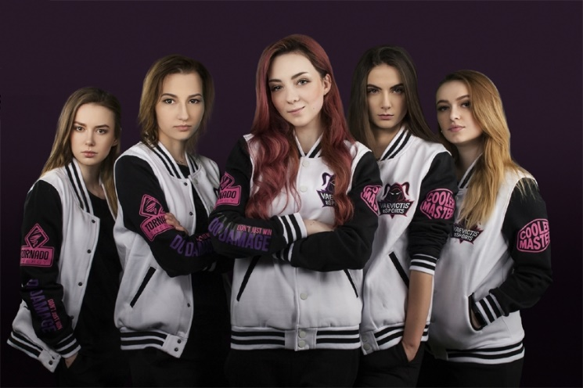

**Issues facing women in gaming and Esport today.**

One of the major issues facing women in Esport is toxicity, as stated by (Adinolf, Turkay, 2018) Players define toxicity as behaviors disrupt their morale and team dynamics, and participants are inclined to normalize negative behaviors and rationalize it as part of the competitive game culture. This isn’t just a challenge; it’s a daily occurrence for the world’s 3.2 billion gamers, with 68% facing “physical, threats, stalking and harassment”. (Sydorenko, 2023). 77% of women responded dealing with at least some sort of frustration when gaming because of their gender. (Daddi, 2021). This coincides with (Intentadigital, n.d.) 28% of gamers who experienced harassment avoided certain games due to their hostile environments. This will drive the female player base out of the gaming community and push future female generations away. Women in Games Argentina sent 3 professional VALORANT players into a match and halfway through the game, enabled a voice changer to sound female; The male players that they were playing with in the lobby just refused to play with them whatsoever (Blake, 2022). This leaves women at a massive disadvantage if they’re own teammates who are there to support each other will not assist one another based on gender and leaves them little room to progress in skill.

Another major issue facing women is the lack of female Esports players for younger generations to look up to, a 2019 study on Gender and Gaming stated that almost half (35%) of the gamer population are female, yet only 5% of that population are considered professional esports athletes (Badillo, 2023). If there are little women in Esports to begin with then it will not be a profession that younger female audiences will look up to and see as a viable career path in the future. Dota 2 has the biggest prize pool in esports but no female player has ever won a world championship. In fact, according to the BBC4, only 0.002% (US $6,300) of the US$235 million awarded in Dota 2 has been won by women (Intentadigital, n.d.). There is also no female players in the top 300 earners and only a tiny fraction of the millions being won in competitions around the world going to women (Zuo, Williams, 2021).

Oversexualization is another issue that impact women every day in gaming and Esports. Miss Fortune is a champion in the popular game developed by Riot games, League of Legends. It has been sufficiently documented that she has unnatural proportions and features to appeal to male audiences, as (Wright, 2015) states [Miss Fortune] has big breasts and a small waist. There are some women with such proportions, but the majority of women do not look like this. This is not the only example of oversexualization, especially in League of Legends; Evelynn is another champion in League of Legends and in a biography written by (Riot Games, n.d) it states, she lures in prey with the voluptuous façade of a human female, but once a person succumbs to her charms, Evelynn’s true form is unleashed. Evelynn’s champion design, similarly, to Miss Fortune is very revealing and unnatural and just like her champion biography, appeals to males. 2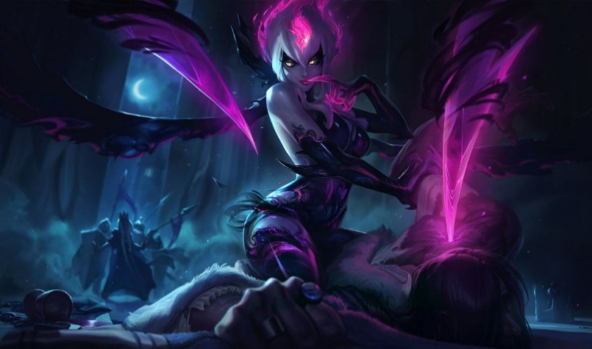

Not only are women oversexualized in gaming, but they are also accused of getting popularity due to their sexuality. As said by Team Liquids own Alina “Alixxa”, “Any support you show another male streamer is because you’re interested in them. Any guy you play with is immediately your boyfriend” in an interview with Forbes. It’s extremely common to see women being romanticized with others in the community and 44% of women gamer respondents have received unsolicited relationship asks while gaming (Daddi, n.d.).

Female discrimination in the top of the Esports ladders is becoming common practice within the industry; Melanie or “MeL” is the second-most decorated in-game leader within the VALORANT Game Changers ecosystem (Rowe, 2023). VALORANT Game Changers is a “stepping stone” meant to promote the women’s VALORANT scene more with the goal of having more women competing in the VCT Challenger Leagues (Datuin, 2023). There is no official ruling that women cannot compete in the VCT (VALORANT champions tour) which is the premiere VALORANT tournament for the best teams in the world. MeL has been turned down trials from VCT teams because, players flat out refused to play with a woman (Moore, 2023).

**Opportunities for women today, and in the future**

VALORANT Game Changers is a “stepping stone” meant to promote the women’s VALORANT scene more with the goal of having more women competing in the VCT Challenger Leagues (Datuin, 2023). VALORANT Game Changers is a league created by VALORANTS developer, Riot games to give recognition to female professional VALORANT players and as stated by (Rozelle, 2021) VCT Game Changers is a new program which will supplement the competitive season by creating new opportunities and exposure for women and other marginalized genders within VALORANT esports. This gives women the recognition and possible entry into the VCT main stage when the time is right. The VALORANT Game Changers league has been steadily growing in viewership and the 2023 finals were watched by a peak of 293,000 viewers, which is an increase of around 50,000 when compared to last year’s 239,000 peak viewers (Simic, 2023). The female professional scene does seem to be rising in popularity gradually even after the average drop in Esports viewership after Covid-19 ended. 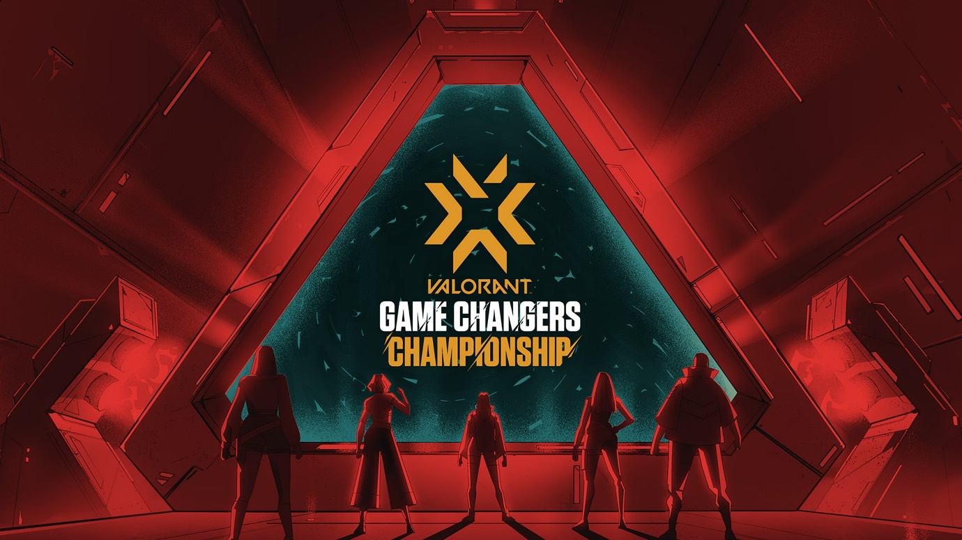

Another opportunity for women in Esports now is the option to work as a content creator on popular media platforms such as YouTube, Twitch, Kick or other platforms. 147 people worldwide have become millionaires through esports, all of them are men. In fact, no women appear among the top 400 players (Rees, 2023). This article is referring to Esport players but does not touch on content creators where Pokimane, is in the top 10 highest earning twitch streamers by ad revenue. Pokimane earns an estimated $18,000 per month, but her net worth is estimated to be a remarkable $25 million (StreamYard, n.d.). Content creation also is aided by skills acquired when aiming to become a professional Esport player. Michael Grezesik or “Shroud” was a professional Counterstrike: Global Offensive player and after 2 years, Shroud retired from professional CS:GO gaming in 2017 in order to focus on streaming (Brooks, 2022). After retiring from professional play, shroud continues to be one of the most popular Twitch streamers and his high skill and personality drive him to have over 16,000 average viewers according to Stream charts.

Esports being an increasingly popular industry that’s constantly growing means there is more and more jobs available outside of professional play that are required to keep the industry afloat. Riot is headquartered in Los Angeles, California and has 4,500+ Rioters (employees) in 20+ offices worldwide (Riot Games, n.d). Although roles are not specified, these employees will have varying tasks ranging from game development to LAN (Local area network) event helpers. There is another opportunity for women to work in Esports in the case of forming teams or organizations that play in professional play, these organizations usually branch to multiple games, have sponsors and draft teams to compete at the top level. 

There is several organizations that are run or owned by women, 100 Thieves, a popular esports organization and lifestyle brand, announced that two of it’s biggest content creators, Rachell “Valkyrae” Hofstetter and Jack “CouRage” Dunlop, will now be co-owners (Peters, 2021). As stated by (Byers, 2023), 100 Thieves, an esports and apparel company, has completed a $60 million Series C funding round valuing it at $460 million. It’s proven that it is still possible to be involved in the Esports without being an Esports player.

VALORANT developed by Riot games has a very broad character pool, unlike other games such as Overwatch, League of Legends or Tomb Raider where the characters are seen with common oversexualization traits and unrealistic standards. VALORANTS cast of characters is a broad spectrum of different nationalities, sexualities and gender. In VALORANT, there is 24 characters or “agents” the player can choose from, 11 of which are female. None of the VALORANT cast is sexualized in any way, there is suggestions of flirtatious relationships but none of which are sexualized and intrude on gameplay in any way. Another point to add, is that in VALORANT the women are not just supports, in fact they are quite the opposite and make up 4 out of the 7 “duelist” roles in the game. Duelist’s in valorant are defined by (Patdu, 2023) stating that duelists act as the entry fraggers of each team. They generally play aggressively and look for early picks and opportunities to kill. This goes against the normal which we have seen before in other games where women are usually supports built to support the more important roles of the team, instead in VALORANT there is an equal balance of supports and self-sufficient marksman. Valorant was released in June 2020, but this was just it’s global release date (Karthikeyan, 2023), due to VALORANT being a new game it is showing that the normal for support to be women is shifting and hopefully a new normal is being formed. 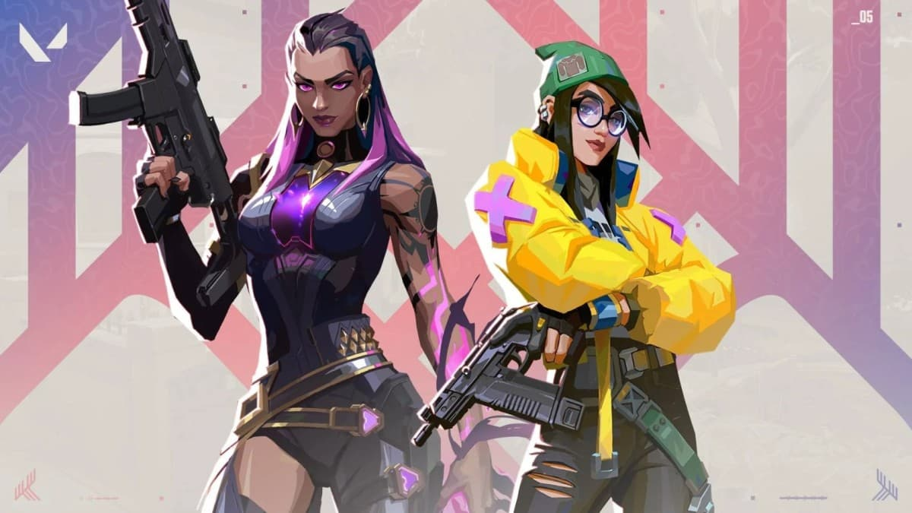

**Conclusion**

Esports is an ever-growing industry that in history has not given equal opportunities to men and women. The drawbacks for women ranging from toxicity, oversexualization and discrimination make it increasingly hard for women to get involved in Esports. Unfortunately, as gaming becomes more popular and more lucrative, more ill practices become normal; According to a 2020 survey, 86% of gamers in the US experienced some form of harassment (MagiWasTaken, 2023). If the toxic behaviour in gaming becomes normal, an increasing amount of young, aspiring professional gamers will be turned away due to increasing amounts of toxicity. This is just one example of ill practice that will push players away and continue to occur with little to no vision on reduction.

There is some hope for the future of women in Esports, the opportunities that are emerging and have emerged before such as women’s Esport leagues, content creation, and involvement in the Esport business. The Esport business is huge and still rapidly growing, if anyone is interested in becoming part of the Esports industry it is becoming ever more possible due to the increased interest and with it, the increased need for Esport inspired employees.

I believe that while Esport is currently an unsafe place for women. The gaming and Esport community are unaccommodating, toxic, and discriminatory towards women at all levels ranging from brand new, casual, gamers to the professionals that are only segregated by gender not by skill. But while at the moment this is the case, this is changing, and I believe that in the coming years this will invert, and women will become more included in Esport with the growing opportunities coming with the growing popularity and economics of the industry.

Adinolf, S. And Turkay, S. (2018) Toxic Behaviors in Esport Games: Player Perceptions and Coping Strategies. Available at: <https://www.researchgate.net/publication/328544495_Toxic_Behaviors_in_Esports_Games_Player_Perceptions_and_Coping_Strategies> (Accessed: 12/01/24)

Asaro, G. (2023) How Long Is An Average Game in League of Legends? Available at: <https://blog.loltheory.gg/league-of-legends-average-game-time/> (Accessed: 12/01/24)

Badillo, K. (2023) How Many Women Gamers Are There In Esports Worldwide? Available at: <https://playtoday.co/blog/stats/how-many-women-are-esports-gamers/#:~:text=A%202019%20study%20on%20Gender,the%20pro%20scene%20as%20athletes> (Accessed: 11/01/24)

Blake, V. (2022) This is how women are really treated in competitive multiplayer games. Available at: <https://www.eurogamer.net/this-is-how-women-are-really-treated-in-competitive-multiplayer-games> (Accessed: 15/01/24)

Brooks, A. (2022) Shroud – Creator profile. Available at: <https://streamhatchet.com/blog/shroud-creator-profile/#:~:text=Shroud%20retired%20from%20professional%20CS,Valorant%20professionally%20with%20the%20Sentinels> (Accessed: 24/01/24)

Byers, J. (2023) 100 Thieves valued at $460M after $60M raise. Available at: <https://frontofficesports.com/100-thieves-valued-at-460m-after-60m-raise/#:~:text=100%20Thieves%2C%20an%20esports%20and,Capital%20and%20Artists%20Capital%20Management> (Accessed: 24/01/24)

Daddi, B. (2021) Reach3 Insights’ New Research Reveals 59% of Women Surveyed Use a Non-Gendered/Male Identity to Avoid Harassment While Gaming. Available at: <https://www.reach3insights.com/women-gaming-study> (Accessed: 12/01/24)

Daniels, T. (2023) The most viewed esports events of 2023. Available at: <https://esportsinsider.com/2023/12/most-viewed-esports-events-2023#:~:text=League%20of%20Legends%20World%20Championship%202023&text=The%20king%20of%20competitive%20esports,esports%20event%20of%20all%20time> (Accessed: 23/01/24)Brain, J. (n.d.) Votes for Women. Available at: https://www.historic uk.com/HistoryUK/HistoryofBritain/Votes-For-Women/ (Accessed: 11/01/24)

Datuin, S. (2023) What is VALORANT Game Changers? Available at: <https://esi.si.com/valorant/what-is-valorant-game-changers> (Accessed: 20/01/24)

Farokhmanesh, M. (2012) First game tournament, ‘Intergalactic Spacewar Olympics,’ held 40 years ago. Available at: <https://www.polygon.com/2012/10/20/3529662/first-game-tournament-intergalactic-spacewar-olympics-held-40-years> (Accessed: 10/01/24)

Francis-Devine, B. And Brione, P. (2024) The gender pay gap. Available at: <https://commonslibrary.parliament.uk/research-briefings/sn07068/#:~:text=Gender%20pay%20gap%20reporting&text=In%202022%2F23%2C%2079%25,for%20women%20as%20for%20men> (Accessed: 11/01/24)

Galiz-Rowe, T. (2023) Male VALORANT pros are reportedly barring female players from VCT try-outs. Available at: <https://dotesports.com/valorant/news/male-valorant-pros-are-reportedly-barring-female-players-from-vct-try-outs> (Accessed: 20/01/24)

Goh, Z. (2023) Everything you need to know about Olympic Esports Week 2023. Available at: <https://olympics.com/en/news/everything-you-need-to-know-about-olympic-esports-week-2023> (Accessed: 10/01/24)

Gough, C. (2023) Revenue of the global eSports market 2020-2025. Available at: <https://www.statista.com/statistics/490522/global-esports-market-revenue/#:~:text=Revenue%20of%20the%20global%20eSports%20market%202020%2D2025&text=The%20term%20%E2%80%9CeSports%E2%80%9D%20is%20characterized,over%201.38%20billion%20U.S.%20dollars> (Accessed: 11/01/24)

Goldman, B. (2017) Two minds, The cognitive differences between men and women. Available at: <https://stanmed.stanford.edu/how-mens-and-womens-brains-are-different/#:~:text=Women's%20reading%20comprehension%20and%20writing,juggle%20items%20in%20working%20memory> (Accessed: 11/01/24)

Henrich, J. And Gil-White, F (2001) The evolution of prestige: freely conferred deference as a mechanism for enhancing the benefits of cultural transmission, pp. 165-195. Available at: <https://www.sciencedirect.com/science/article/abs/pii/S1090513800000714?via%3Dihub#aep-section-id46> (Accessed: 10/01/24)

Hunter, S. (2023) The Biological Basis of Sex Differences in Athletic Performance. Available at: <https://www.acsm.org/news-detail/2023/09/29/acsm-releases-expert-consensus-statement-the-biological-basis-of-sex-differences-in-athletic-performance#:~:text=Biological%20sex%20is%20a%20determinant,in%20athletic%20performance%20are%20minimal> (Accessed: 11/01/24)

Intentadigital (n.d) The Problem with Women in Esports. Available at: [https://intenta.digital/esports/women-in esports/#:~:text=Lower%20earning%20capacity%20than%20men,has%20been%20won%20by%20women](https://intenta.digital/esports/women-in%20esports/#:~:text=Lower%20earning%20capacity%20than%20men,has%20been%20won%20by%20women) (Accessed: 14/01/24)

Karthikeyan, K. (2023) When did Valorant come out? Available at: <https://www.oneesports.gg/valorant/when-did-valorant-come-out/> (Accessed: 24/01/24)

Larch, F. (2023) eSports History: How it all began. Available at: <https://www.ispo.com/en/sports-business/esports-history-how-it-all-began#> (Accessed: 10/01/24)

MagiWasTaken. (2023) What is toxicity in games? Available at: <https://indiecator.org/2023/09/27/what-is-toxicity-in-games/#:~:text=or%20harmful%20behaviours%E2%80%9D.-,Rationalizing%20Toxicity,This%20is%20worrying> (Accessed: 24/01/24)

Malliet, S. And De Mayer, G (2011) Handbook of computer games. Available at: <https://books.google.co.uk/books?hl=en&lr=&id=ErhNEAAAQBAJ&oi=fnd&pg=PA23&dq=the+first+video+game&ots=jxZj7Z8irc&sig=w4GF1MbsParinZSG5o3pg5mOa1A&redir_esc=y#v=onepage&q&f=false> (Accessed: 10/01/24)

Mock, B. (2021) The Real Story of Vaevictis eSports. Available at: <https://sportsuntold.substack.com/p/the-real-story-of-vaevictis-esports#:~:text=In%20the%20world%20of%20esports,over%206%20million%20combined%20views> (Accessed: 12/01/24)

Moore, B. (2023) meL “Mortified” to be at the center of claims that VCT teams are refusing to trial women. Available at: <https://esports.gg/news/valorant/mel-mortified-to-be-at-the-center-of-claims-that-vct-teams-are-refusing-to-trial-women/> (Accessed: 20/01/24)

Patdu, A. (2023) All Valorant Roles: A Valorant Class Guide. Available at: <https://www.zleague.gg/theportal/all-valorant-roles-a-valorant-class-guide/> (Accessed: 24/01/24)

Peters, J. (2021) Valkyrae and CouRage are now Co-ownders of 100 Thieves / They join Nadeshot, Drake, Scooter Braun, and Dan Gilbert as co-owners. Available at: <https://www.theverge.com/2021/4/7/22372759/valkyrae-courage-100-thieves-co-owners-nadeshot> (Accessed: 24/01/24)

Ratan, R. And Et, Al. (2015) Stand by Your Man: An Examination of Gender Disparity in League of Legends. Volume 10, Issue 5. Available at: <https://journals.sagepub.com/doi/abs/10.1177/1555412014567228?journalCode=gaca> (Accessed: 11/01/24)

Rees, L. (2023) No women are among 400 highest-earning esport players. Available at: <https://www.pocketgamer.biz/news/80725/no-women-are-among-400-highest-earning-esports-players/> (Accessed: 21/01/24)

Riot Games. (n.d) Evelynn, Agony’s embrace. Available at: <https://universe.leagueoflegends.com/en_GB/story/champion/evelynn/#:~:text=Within%20the%20dark%20seams%20of,gratifying%20herself%20with%20their%20pain> (Accessed: 20/01/24)

Riot Games. (n.d) Who we are. Available at: <https://www.riotgames.com/en/who-we-are#:~:text=Worlds%20is%20the%20most%20widely,Rioters%20in%2020%2B%20offices%20worldwide> (Accessed: 24/01/24)

Rozelle, W. (2021) VCT GAME CHANGERS. Available at: <https://playvalorant.com/en-us/news/esports/vct-game-changers/> (Accessed: 20/01/24)

Simic, I. (2023) VCT 2023 Game Changers sees viewership jump, beats previous record. Available at: <https://esportsinsider.com/2023/12/vct-2023-game-changers-viewership> (Accessed: 20/01/24)

# Sirotin. (2024) The Rise Of TheESPORTS Industry: A Glimpse Into Competitive Gaming’s Explosive Growth. Available at: <https://www.ecgprod.com/the-rise-of-the-esports-industry/#:~:text=Essentially%2C%20eSports%20involves%20competitive%20gaming,of%20the%20gaming%20industry%20basics> (Accessed: 10/01/24)

StreamYard. (n.d) How Much Money Do Twitch Streamers Make in 2023? Available at: https://streamyard.com/blog/live-stream-business/how-much-do-twitch-streamers-make (Accessed: 21/01/24)

Sydorenko, D. (2023) Toxicity in gaming: unveiling the ‘Closed Club’ and revolutionising cooperative play. Available at: <https://www.maddyness.com/uk/?p=724078#:~:text=Since%202021%2C%20reports%20of%20toxic,gaming%20space%20due%20to%20toxicity> (Accessed: 12/01/24)

Tyler, J. (2020) League of Legends: The Official Champion Difficulty Tier List. Available at: <https://blogoflegends.com/2020/11/22/league-of-legends-champion-difficulty-tier-list/> (Accessed: 11/01/24)

Wright, S. (2015) Why I don’t play League of Legends: sexualization. Available at: <https://www.gameskinny.com/opinion/why-i-dont-play-league-of-legends-sexualization/> (Accessed: 20/01/24)‌

Zuo, N. (2021) Esports: Why are there so few professional women gamers? Available at: <https://www.bbc.co.uk/news/av/technology-58466374> (Accessed: 15/01/24)