Ranked
By: 2305626

There are 2 ranked game modes in League of Legends, those modes are ranked flex and ranked solo/duo, ranked flex while is a competitive mode is not fully respected due to the presence of account boosting, smurfing and unbalanced matchmaking, while ranked solo/duo is seen as the more impressive and difficult mode to climb in and would be the mode I chose to prioritize.
I had played ranked before university started but by no means was it a game I was focusing on, it was a game I would exclusively play for fun and for short periods of time with no focus on improving. I would play jungle for the most part but would dabble in other roles here and there as I wasn’t taking it too seriously and would play for fun. I had a 58%-win rate in jungle and did find it the most enjoyable, notably finding the champions Viego and Kayn the most fun. I would start university with a peak rank of silver 4 which came after playing league for around 2 years on and off.
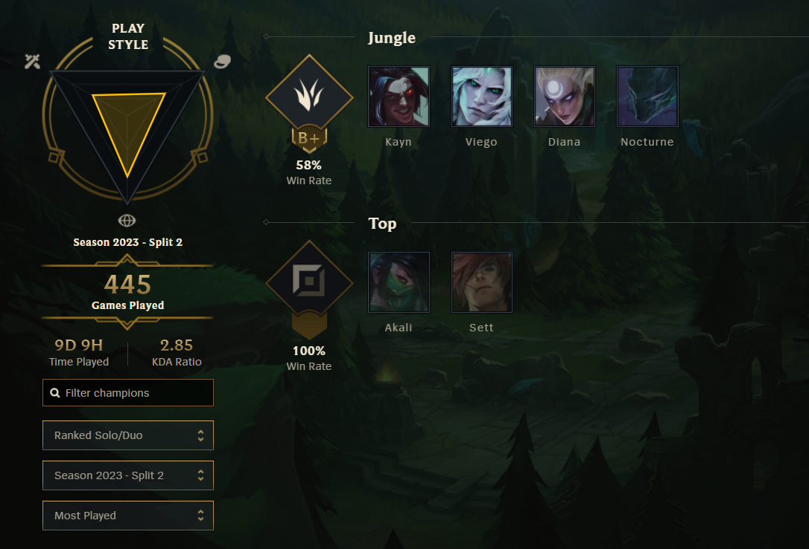
Figure 1 Champions played and win rate per role.
When university first started, I had little interest in League of Legends and was more focused on improving at VALORANT which at the time was my better game by a long way so I would continue to play ranked games for fun and not focus on improving. Although I wasn’t taking league too seriously, I wanted to get as much competitive experience as I could, so I enrolled to try out for the League team in October of 2023. I played 2 games in try outs and put myself forward as jungle as first role and mid lane as secondary with the goal of making any team but preferably making first team. First game I played I clicked well with Jamie Clegg and playing for top side we won but a huge margin.

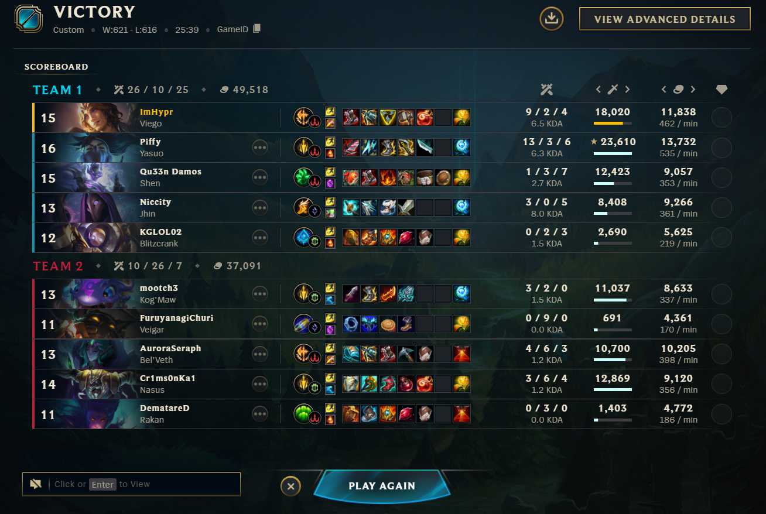
Figure 2 Trials game 1.
The second game I played, I was in Mid lane with different ally teammates and different opponents. Mid lane while not my most comfortable role was what I considered my secondary, but I was severely limited in terms of micro and macro game sense. In Mid lane not only was my skill limited I also had a limited champion pool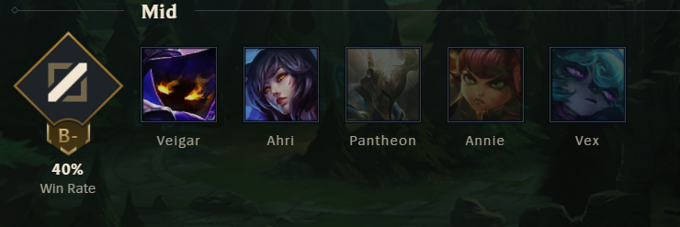
Figure 3 my mid lane champions in ranked.
In ranked at the time I had a champ pool of a realistic 4 champions I was comfortable and those where Ahri, Veigar, Akali and Vex. Unfortunately, it was very clear who my comfortable main champions where and so the enemy team banned Vex, Ahri, Akali, and stole the Veigar pick from me. This left me to pick Annie who I was starting to learn at the time but wasn’t fully comfortable with yet.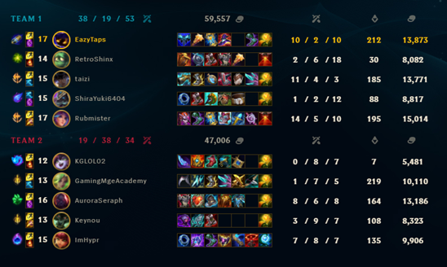
Figure 4 trials game 2.
I was hindered in the early laning phase against the more experienced Mid laner, Sven. But late game I was able to use my utility to assist the team in fights, although this was with little success as in the end we did lose by a large margin. After try outs I was placed on a second team with 9 other players and there was no word on when or if we were playing so I would dedicate more time to ranked.

I had been playing League more and more since September, but queuing ranked very rarely resulting in a slow climb and little improvement made. After talking more with League players at university I decided to start taking it seriously after November. 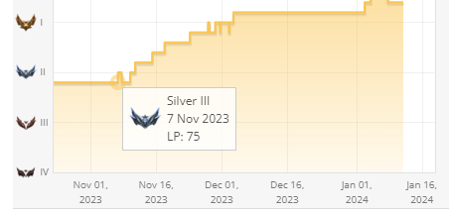
Figure 5 graph of my rank over time.
I started out as silver 3 but had around a 70%-win rate when I did play. Due to having such a high win rate I would just play as many games as I could and would climb extremely fast due to this. 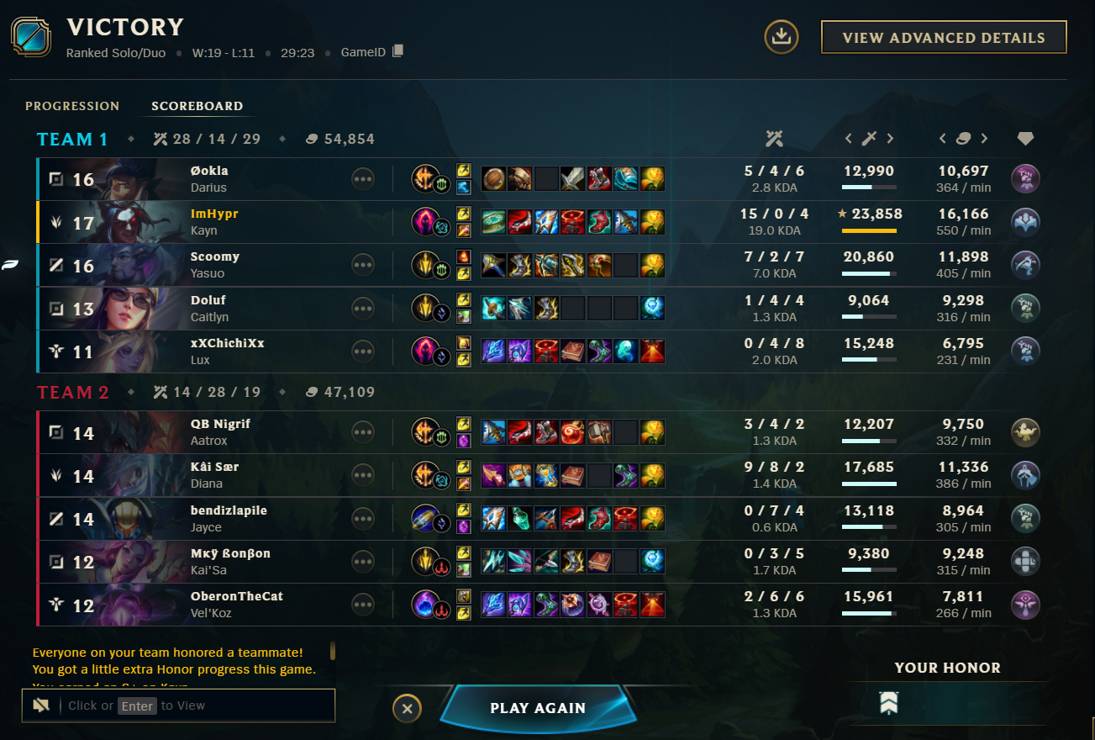
Figure 6 ranked game in silver.

Most games I would end up being ahead and due to my knowledge of how to play early game and counter the enemy jungles play I would snowball and become unstoppable near the end. For this reason, Kayn and Viego work best for my playstyle as they are what’s considered as “Carry champions”. These champions can scale well and with an early lead will dominate all stages of the game and be very selfish which works well in the lower elos where teammates may not be the smartest.

Kayn also has the unique ability to flex what type of champion he is mid game; Damaging ranged champions charges the Shadow Assassin, and damaging melee champions charges the Darkin Slayer. At full charge, Kayn can permanently transform at his fountain. (League Of Legends, n.d.). Viego is more like Kayn’s Rhaast form where he acts more as a bruiser and “Tank shredder”. He has the unique passive of being able to take the form and abilities (excluding ultimate) of the champions he takes down, along with getting a percent of the enemies hp as regeneration on possession. These champions fill most roles in the team that I can play excluding tank, allowing me to flex and confirm an optimal champion and build for any game.
I would continue to play Kayn and Viego with huge success until gold 2 where I started to struggle and lose my 70%-win rate. I started to be more careful on queuing games as I learnt that I was become more tilted after every loss and after a loss streak, I would play worse starting a cycle. A factor that has been shown to influence performance in sport is the way athletes cope with stressors they encounter (D Poulus, Et Al. 2019). I found out that after 2 losses in a row I would be tilted enough to start the cycle, so I used the logic of queueing until 2 losses in a row and then take a small break doing something else entirely until I had cooled off. I also applied this logic to winning games as well adopting a 3 game per session maximum 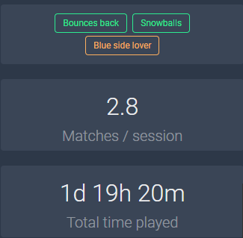
Figure 7 screenshot of Porofesssor (A league Of Legends stats viewer) with matches played in a session.
Another way I found to improve after getting to gold was by learning itemization and creating my own builds game by game. Items play a huge factor in league of legends and can completely change what playstyle your champion has. Items all have different effects and stats and while there is in theory optimal builds for most champions it may not be optimal for each game. Before learning, I would use a website called U.gg, it had default runes and builds for each game and without fail I would use the builds listed on there for each champion and this was the standard for most players in gold. I would end up creating my own rune pages for Viego and Kayn, For Viego I would change small details of the default rune page to suit my playstyle; For instance, I changed from the usual “inspiration” secondary page to domination which gave me more of a snowballing play style as when I get a before 10 minutes (early game) I find the game is increasingly high in my favour compared to other people. 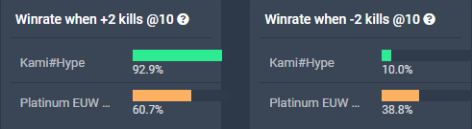
Figure 8 win rate when ahead in kills and behind in kills.
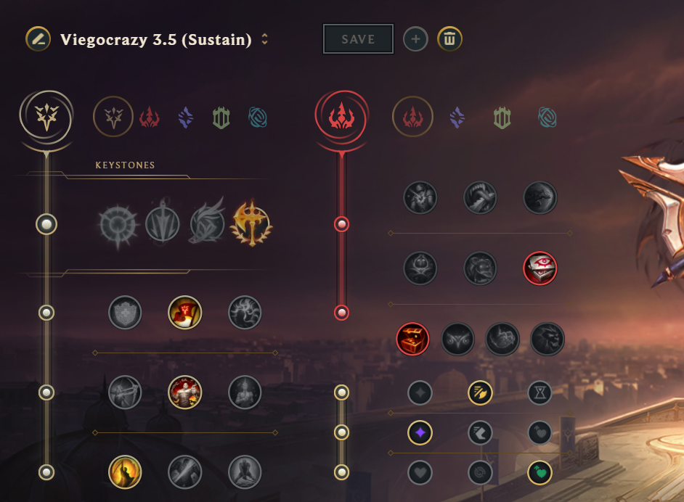
Figure 9 Viego runes I made.
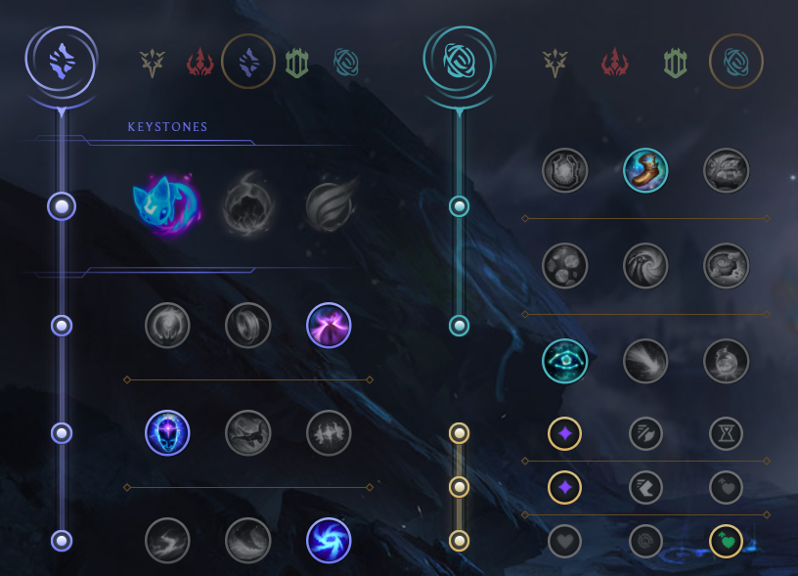
Figure 10 Kayn runes I made.

Itemization assisted to my ranking up by allowing me to counter the enemy a lot better than if I had just gone for default builds. When you learn itemization, it becomes clear that each attribute that a champion has can be countered in some way and sometimes used against them. For instance, crowd control is a huge issue for assassins due to the high damage but low hp they have, if they get caught by any form of crowd control it’s very likely to cause death, but with an item that can block crowd control you’d be able to get hit once and while their crowd control ability is on cooldown take them down. Examples of my Viego builds https://www.mobafire.com/league-of-legends/build/viego-crazy-season-14-14-6-634715

Figure 11 ranked win in gold 2.
After this hurdle it was a continuous climb until gold 1 where I started to drop in performance again, this time I believed I was reaching the peak of my skill as I noticed my usual strategy of playing risky and using my mechanical skill over the opponent lose its effectiveness.
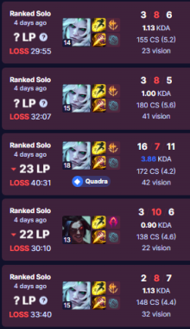
Figure 12 Ranked games in gold 1.
Due to this reason I would focus on reviewing my games once I had finished my 3 games. I would review the games I thought where the worst of that session and take into consideration what went wrong and information I possibly missed. After reviewing the games I found that some big problems I had where over commiting for objectives, a lack of map awareness, and over aggression in fights. Due to the over aggression and commitment, I would be ahead and build up a large shutdown that would be given away for the chance of an objective we could have gone for at a safer time. I’d adopt a play style of debating if an engagement was worth it before it started, for example; I would see an opportunity come and would take into consideration, the champion match up, player advantage, my teammates position, if a fight had any need and more. This resulted in me becoming a much more safer player but the fights I did take had higher impact.

With that knowledge, I would rank up to platinum with ease. Though the games leading up to platinum where not as impressive to look at numbers wise the contributions I had could not just be shown through KDA and what KDA I did have was more calculated and had higher impact than if I had 30 kills.
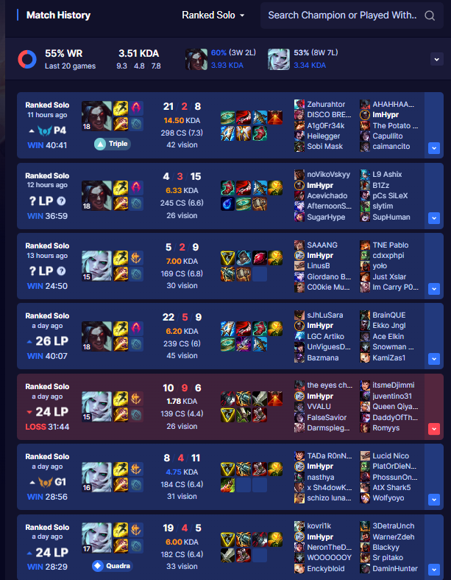
Figure 13 leading games to rank up to platinum 4.
After reaching Platinum in League of legends, I would take a small break and wouldn’t try to rank up until January of 2024 when the ranked reset occurred. This “reset” would usually bring a persons rank down a division (e.g. gold 4 to silver 4). But for me, the reset only reset my MMR giving me more LP per win and kept me in platinum 3.

Each season in league has 2 “splits” and between each split there is a reset and between each season there is huge changes the completely shift the meta of the game. Season 2024 brought an item overhaul, huge map changes, an additional objective and changes to the existing void based objectives. This season changed how every champion I play builds there items and also completely reworked Jungle. Due to this, I took a long time to learn what to build and would prioritize using ranked as practice instead of my main focus and shifting onto NSE and NUEL. Although I have been using ranked as a practice tool, I’ve been up and down shifting between platinum 3 and 2 for the last few months but have been steadily improving my winrate.

My goal for ranked when I first started was to hit gold, and I managed to hit platinum in a span of 20 days going from silver 4 to platinum 3. I believe going into the summer season I will focus on improving my overall game knowledge (I am still lacking in this due to how new I am to League of Legends) and improving my team fighting abilities. Overall I would say that the first year of university was a huge success for the improvement of my skill and climb in League Of Legends.

NSE and NUEL

I didn’t start the year by playing in NSE and NUEL, I was a “player” on the second team for a month or so but never was contacted abnout playing nor did anything come of it. My first experience in NSE and NUEL was with the second team at the time; “Baron Nyashers” I was asked to sub in for 4 games in Jungle. Both games I believe I played well but the team was definitely missing some coordination and synergy which will be in part due to me being new and possibly playing differently to their main Jungler at the time. 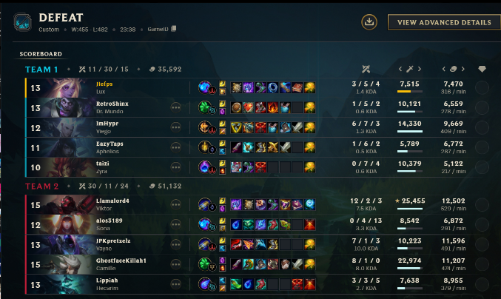
Figure 14 NSE and NUEL games I subbed in for Baron Nyasher.

It would only be in November that I would get the chance to play in NSE and NUEL for a team permanently which was for “F Red Kayn”, the old team had some complications so there was a shift in who was playing for the team resulting in me being brought in as the new Jungle. At the start everyone was very passionate on playing and we would practice every week alongside playing NSE and NUEL. 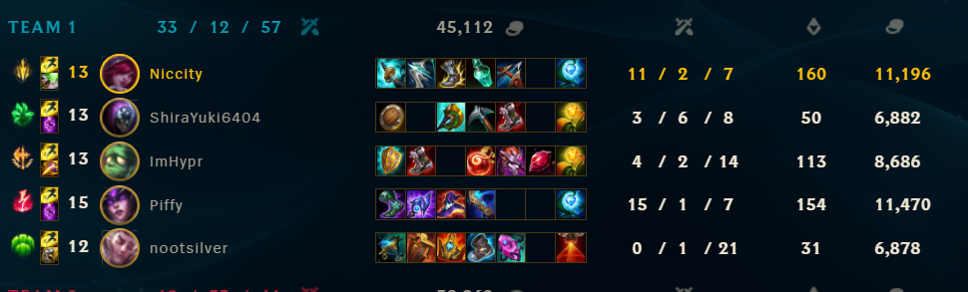
Figure 15 practice games before NSE and NUEL
We started practicing by focusing on showing our strongest champs and what we would like to play. This resulted in us all having a good understanding of who each other can play and allowed us to make team compositions around them.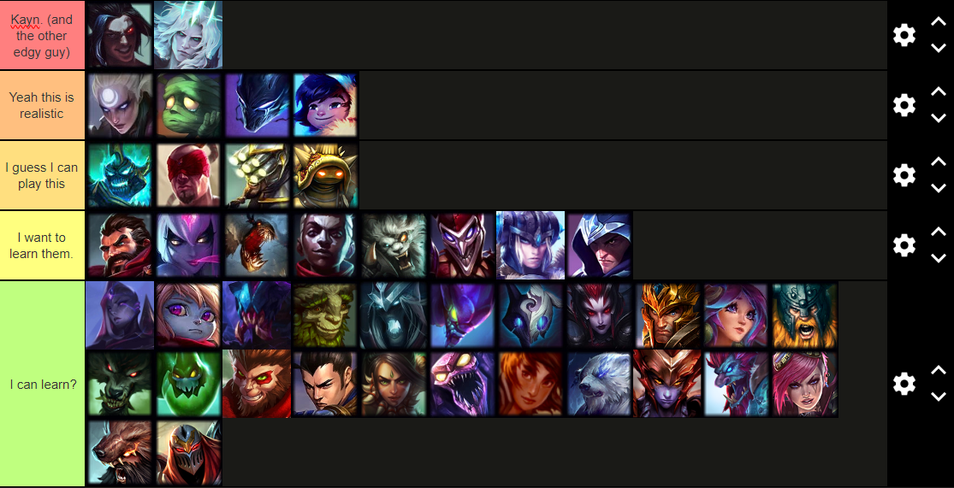
Figure 16 my personal jungle tier list.
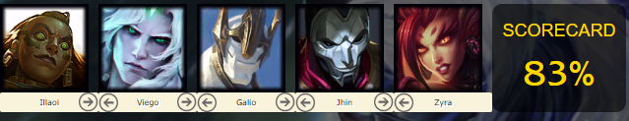
Figure 17 example team composition from F Red Kayn

Using this, every game we had an idea of who we where playing and the team composition we would like to follow that match. The downside to this was that if a champion got banned we wanted to play, we would stress and throw out the idea of using the team composition that was pre set. This made us stiff and set in stone on these team compositions and when we couldn’t abide to them we struggled. A personal complaint I had with these team comps was that in most cases, I would be playing a tank jungle, while I can play these champions I believe and our coach Ruben believed that I would have a greater impact on a “carry” champion that could make plays alone and deal high amounts of damage. This resulted in me getting very bored of these tank jungles and resenting playing certain champions like Rammus or Ammumu.

We would continue practicing for NSE and NUEL every week and scrimmed the second team during skills development. This resulted in us scrimming the Baron Nyashers so often we felt as though it was getting repetitive and predictable what champions we would play and the playstyle we would take. We decded to do a best of 3 that we won 2-1 and after that slow down on scrims and practice as a whole due to a player not liking the environment in the SIZ and resulting in more stress. We also found that practicing in the afternoon had the likelyhood for some players to have a reduced performance later in the evening which did reduce the hours we could reasonably practice and later NUEL games would mean a reduction in performance.

The games wouldn’t go great and we would sit at around a 25% winrate between NSE and NUEL. I found that transitioning between playing alone to playing in a coordinated team was very difficult as I naturally was a very quiet person in practice and in game early on. This resulted in me not being as vocal at times and meaning we would lose out on certain objectives and fights. This only got worse when I knew I was having a bad game and would become even more closed off, sometimes not speaking until the game was over. This was something I tried to work on throughout the year as it was crucial that in jungle I had better communication with my teammates.
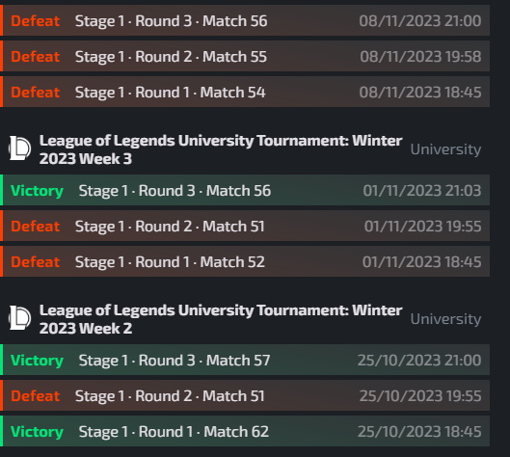
Figure 18 NUEL match history.

A big issue that I found near the end of the split was that I was under a lot of pressure from my team to help their lanes, and in part due to me being quiet it in games it resulted in me going to help when it was not optimal and leaving me behind in the late game due to me not having the time to farm in the early game and instead prioritizing plays that weren’t there. It was a huge burdon to me that not only made me play worse in game but effected me mentally causing a large amount of resentment to jungle and helping the lanes became very scary to do on the chance it went wrong.
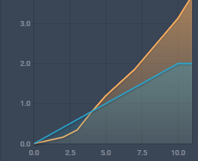
Figure 19 average ganks between me and average platinum (I am blue, average is yellow)

Nearing the end of the season I was experiencing burnout and realised that I should take a break from the game and figuring out why I was burnt out. I boiled it down to playing too much tank jungle Remember, too much of anything can be grow tiresome – even if it’s a thing you love. (James He, November 2020). Going into the new split; Me, Jamie and Nic where kept on first team and had Roshan and Sven brought on. The team had an immediate improvement in base skill in my opinion and the synergy was there from the start, I think an issue with F Red Kayn was that everyone was too nice to the point where we didn’t give any feedback unless our coach Ruben was interviening. Meanwhile, in the new team dubbed “Remgar Gaming” we where a lot more open and had discussions on what went wrong in the games.

The new team was extremely successful compared to F Red Kayn, even though we started behind due to the team before F Red Kayn having a negative win rate, we didn’t do great and where still negative win rate in total. The start of Remgar Gaming wasn’t the best due to us having 2 weeks at the start without the full team due to some players not being available because of other commitments. Once we did get games in as a team we where winning with around a 60% winrate. I decided I would stream each game we played which allowed me to sit down and vod review myself more than I could in F Red Kayn alongside slowly growing my precense on twich as an added bonus.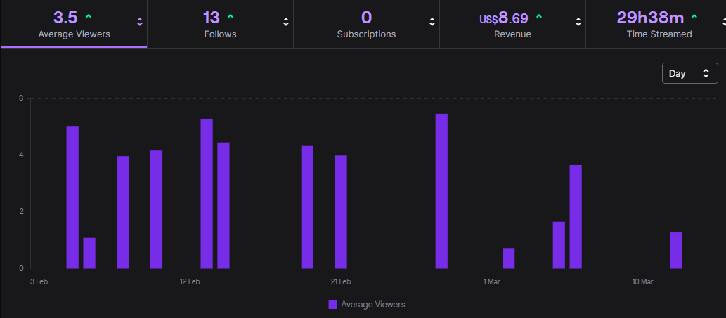
Figure 20 my twitch statistics between February and March
As a team, we collectively decided to scrap the set in stone team composition idea and instead work before champion select, flexing around who wanted to play certain champions on the day and what we think would synergise well. This allowed us to play much more flexibly and allowed me in particular to scarecely play tank jungle which meant I had more impact on the outcome of the game instead of being a roaming support.
Although we where winning more and more as the weeks went on, it was clear that halfway through we would need an in game leader to make calls on when we should make plays across the map. This never happened fully even after trying due to various reasons meaning we stayed with a no in game leader play style which I believed was sub optimal leading to situations where the communication was the reason we lost. In future teams, I will try and put myself forward as an in game leader as it is the standard for jungle players to be in game leaders due to their map precense being the biggest across all the lanes.
Nearing the end of the season, I had more discussions with Ruben about vod reviewing and asked them to look over some games with me. I had siginificently improved in skill and confidence but the lingering safety from not ganking in F Red Kayn was there. I had also developed a “too safe” mindset. Decades of psychological research consistently show that mere repetition of a simple action in a consistent context leads, through associative learning, to the action being activated upon subsequent exposure to those contextual cues. (J Gen December 2012)
Also nearing the end of the season, I would start drinking one energy drink 30 minutes before our NSE and NUEL tournaments which would result in me getting the kick from the caffeine at the peak time according to (H Whiteman, August 15th 2015) “Over the next 15-45 minutes, caffeine levels in the bloodstream peak.”

Overall, we ended the season placing top 40 in NUEL and top 60 in NSE and only climbed in win-rate during the later weeks. I met my goal with NSE and NUEL by joining a team at all and reaching the top 50% in the leagues was a huge achievement for me. I also believed that playing in NSE and NUEL boosted my confidence and skill as a player in both coordinated play and solo play.

Kayn passive ability summary. (League Of Legends) (n.d.) Accessed 23rd of March. Available at: https://www.leagueoflegends.com/en-gb/

Stress and coping in Esports and the Influence of Mental Toughness. (D Poulus, Et Al) (December 2019) Accessed 24th of March: https://www.ncbi.nlm.nih.gov/pmc/articles/PMC3505409/#b7

Video game burnout: how to detect and cure gaming fatigue (James He) (17th of November 2020) Accessed 24th of March. Available at: https://happymag.tv/video-game-burnout/
Making health habitual: the pyschology of ‘habit-formation’ and general practice. (J Gen) (December 2012) Accessed 24th of March, Available at: https://www.ncbi.nlm.nih.gov/pmc/articles/PMC3505409/#b7

How energy drinks affect your body within 24 hours. (H Whiteman) (August 15th 2015) Accessed 24th of March. Available at: https://www.medicalnewstoday.com/articles/298202

